DEPARTMENT OF BASIC SCIENCES AND ISLAMIAT
University of Engineering and Technology, Peshawar

Paper : Complex Variables and Transforms (BSI-362)
Final-Term Examination Summer-2020
(Computer System Engineering)
Time Allowed: 3 hours Max Marks: 60

Note: Attempt all questions:

Question No 1 (CLO-1, C1, PLO-1 6+6)
(a) Find Laurent series of 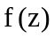 near a singularity at 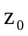where 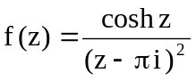 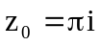
(b) Find all zeros and order of zeros of the function 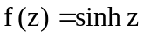

Question No 2 (CLO-1, C1, PLO-1, 6+6)
(a) Solve the integral (counterclockwise) 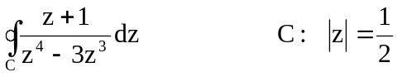
(b) Solve the integral 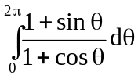

Question No 3 (CLO-2, C3, PLO-2, 6+8)
(a) Solve the improper integral 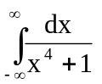
(b) Find the Complex potential field  between two infinite coaxial cylinders of radii
and having potentials 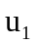and 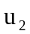 respectively,
where 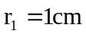, 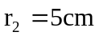, 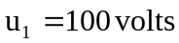

( P T O)
Question No 4 (CLO-2, C3, PLO-2, 6+6)

(a) Find Fourier series of the periodic function 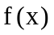0f period p where
(b) Find Fourier transform of 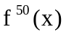 where 